**Less command :**to show single pages as result.

Enter key is used to navigate to next line

space key is used to navigate to next page

b key is used to go back

q key to quit

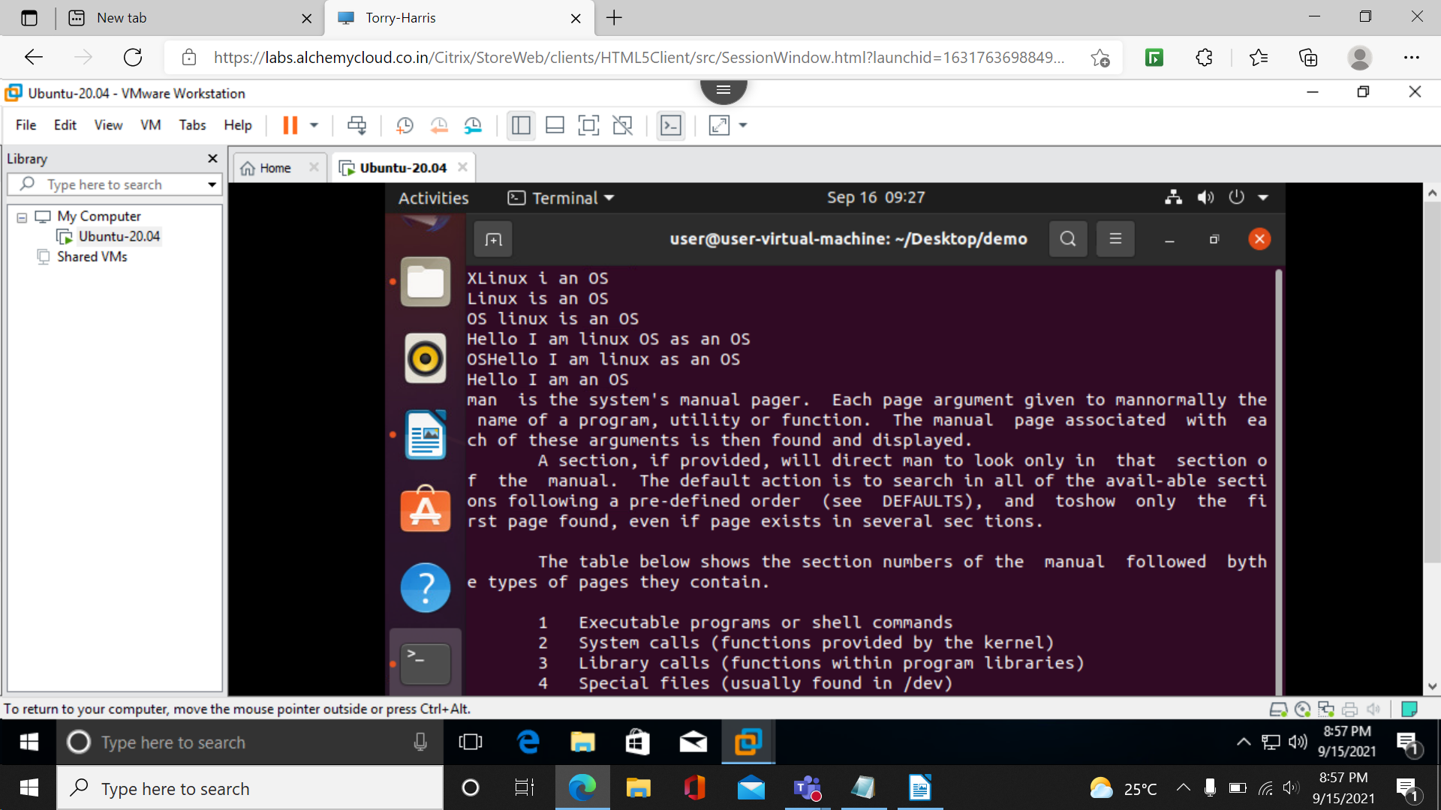less filename

less -N filename

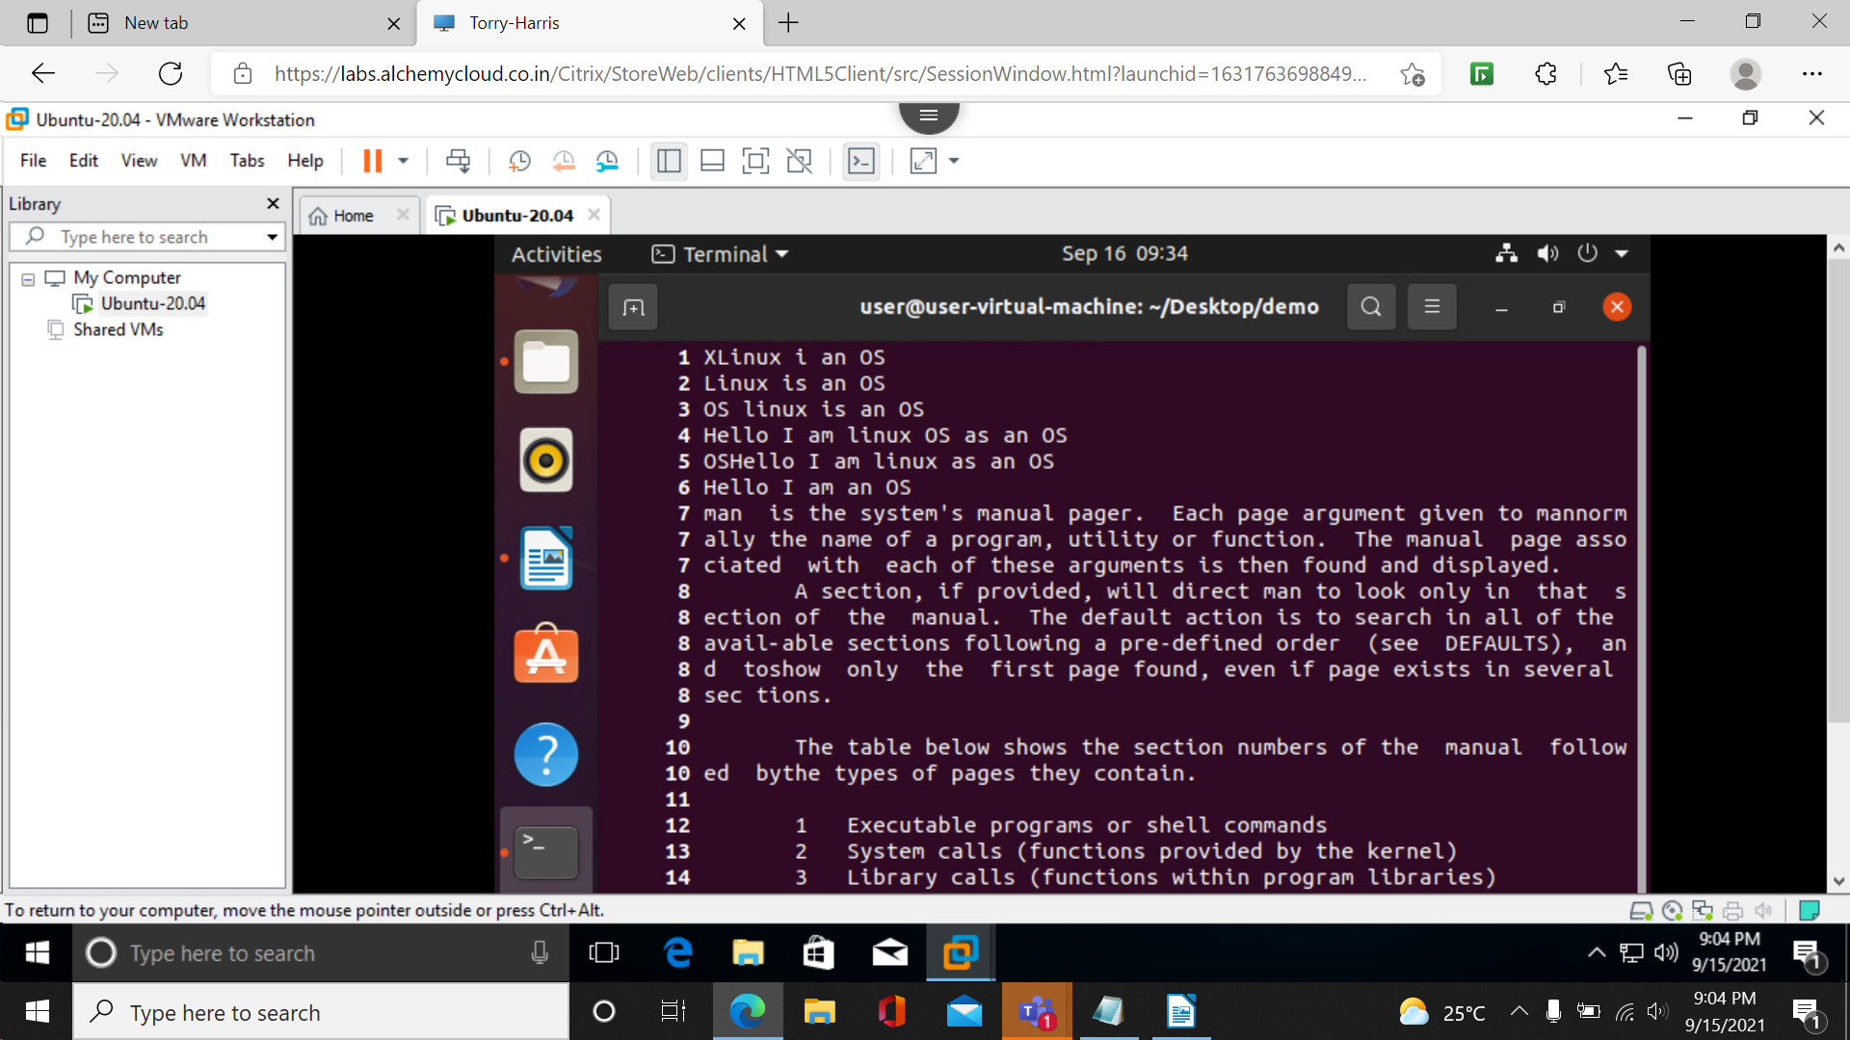 to display with line number.

less -p ‘String_to_search’ filename:

used to find a word in text file.

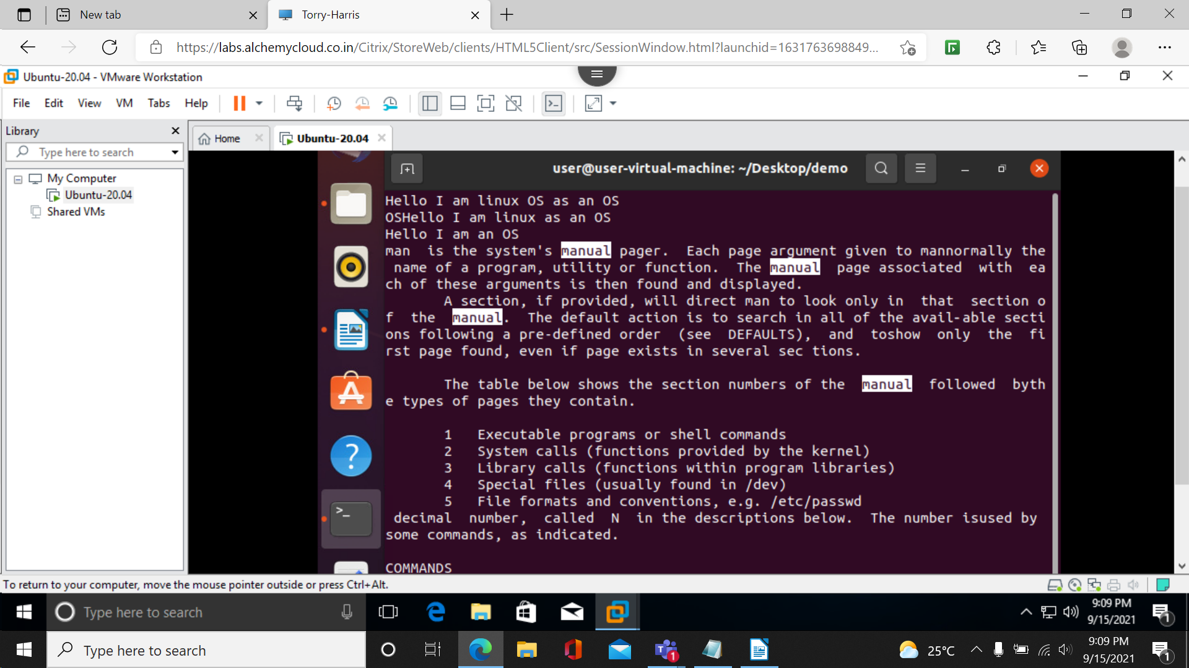

**Vim Editor:**vim is advanced and highly configurable text editor built to enable efficient text editing

sudo apt install vim-nox

which vim to confirm that vim is installed.

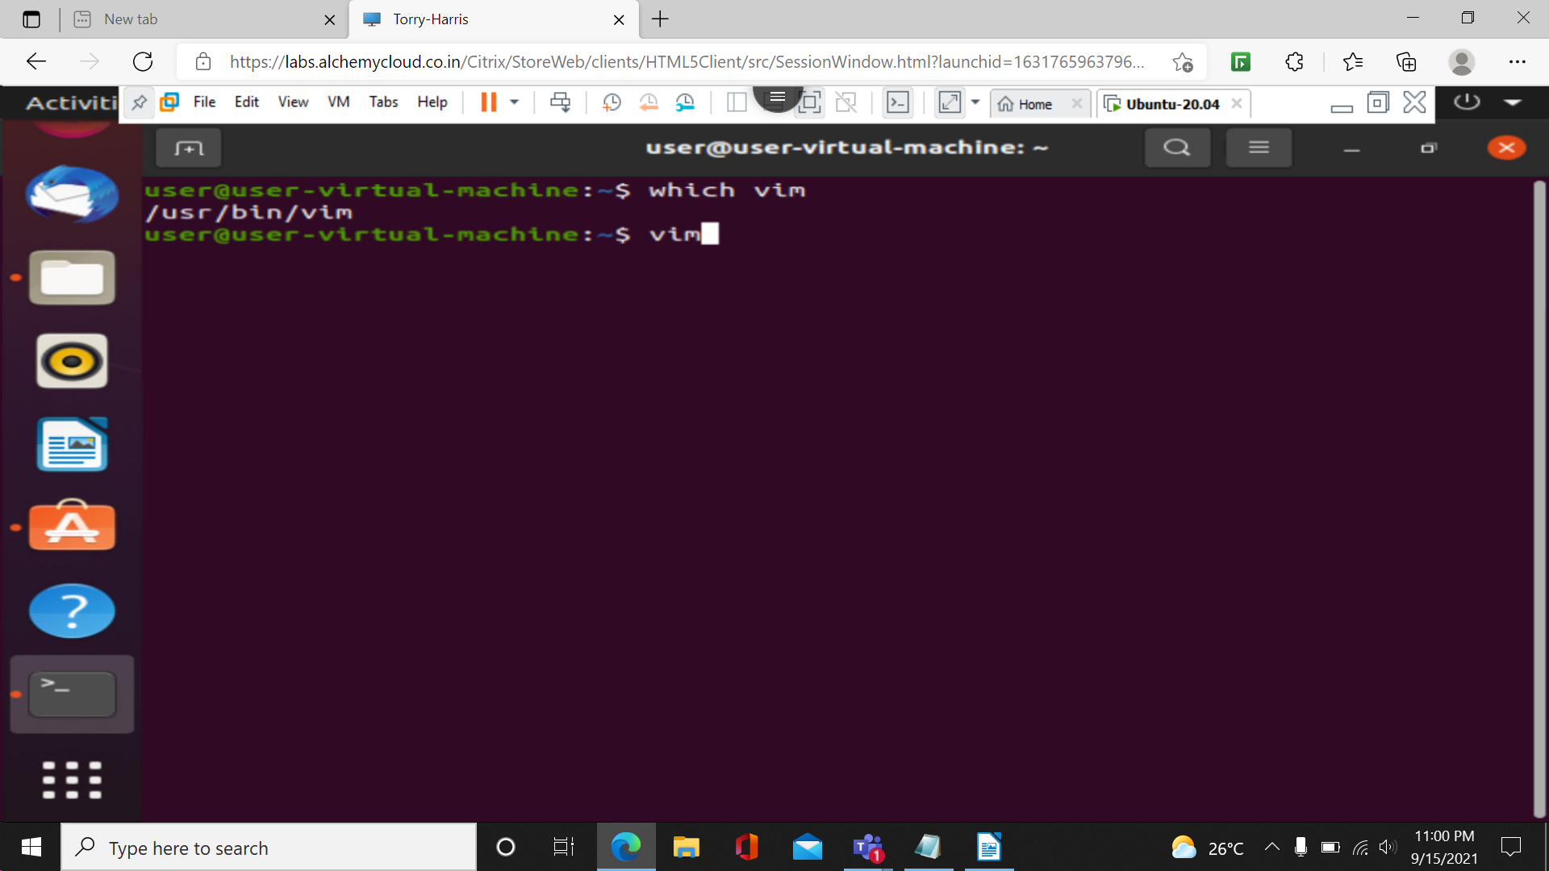

Vim command to enter into the vim text editor.

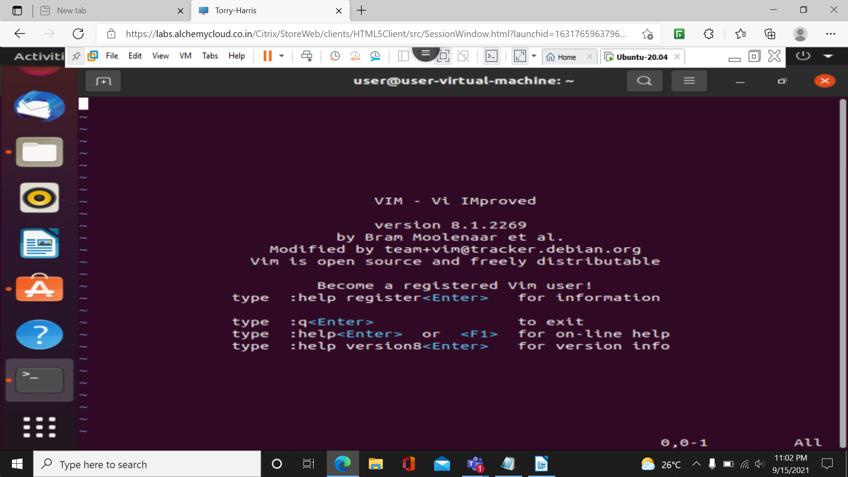

I,a,A:to get into insert mode.

Escape key to execute commands in vim

u undo

x to delete word by word:

:w filename: to save into a file

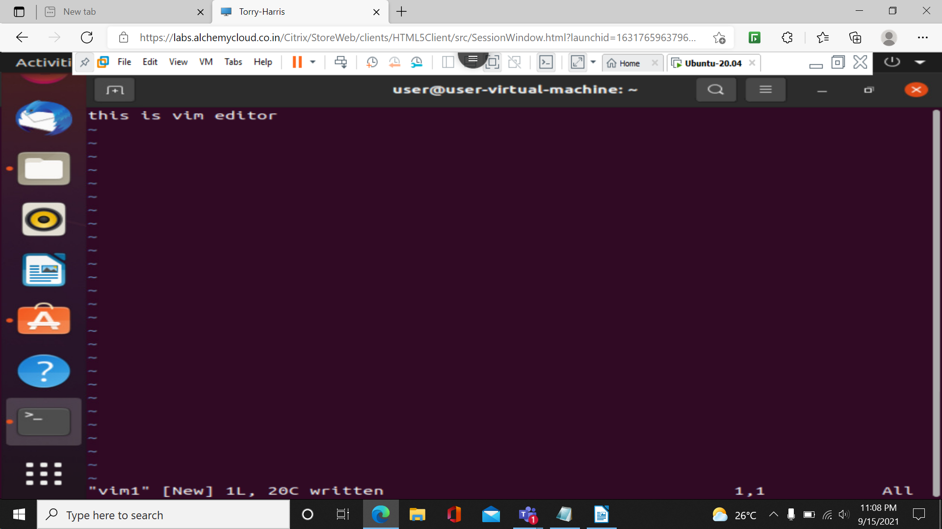:w new_filename==> to save

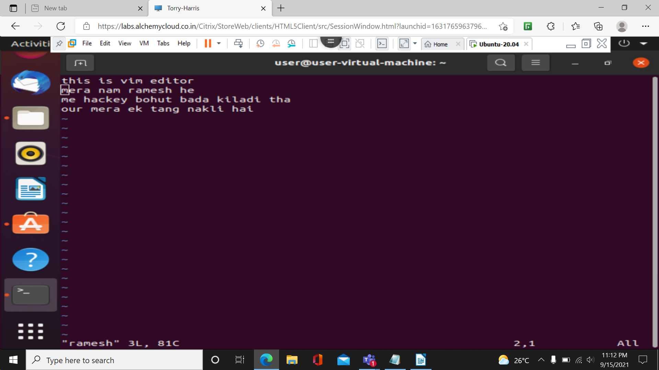:r filename to copy content in file

:q! no data is saved

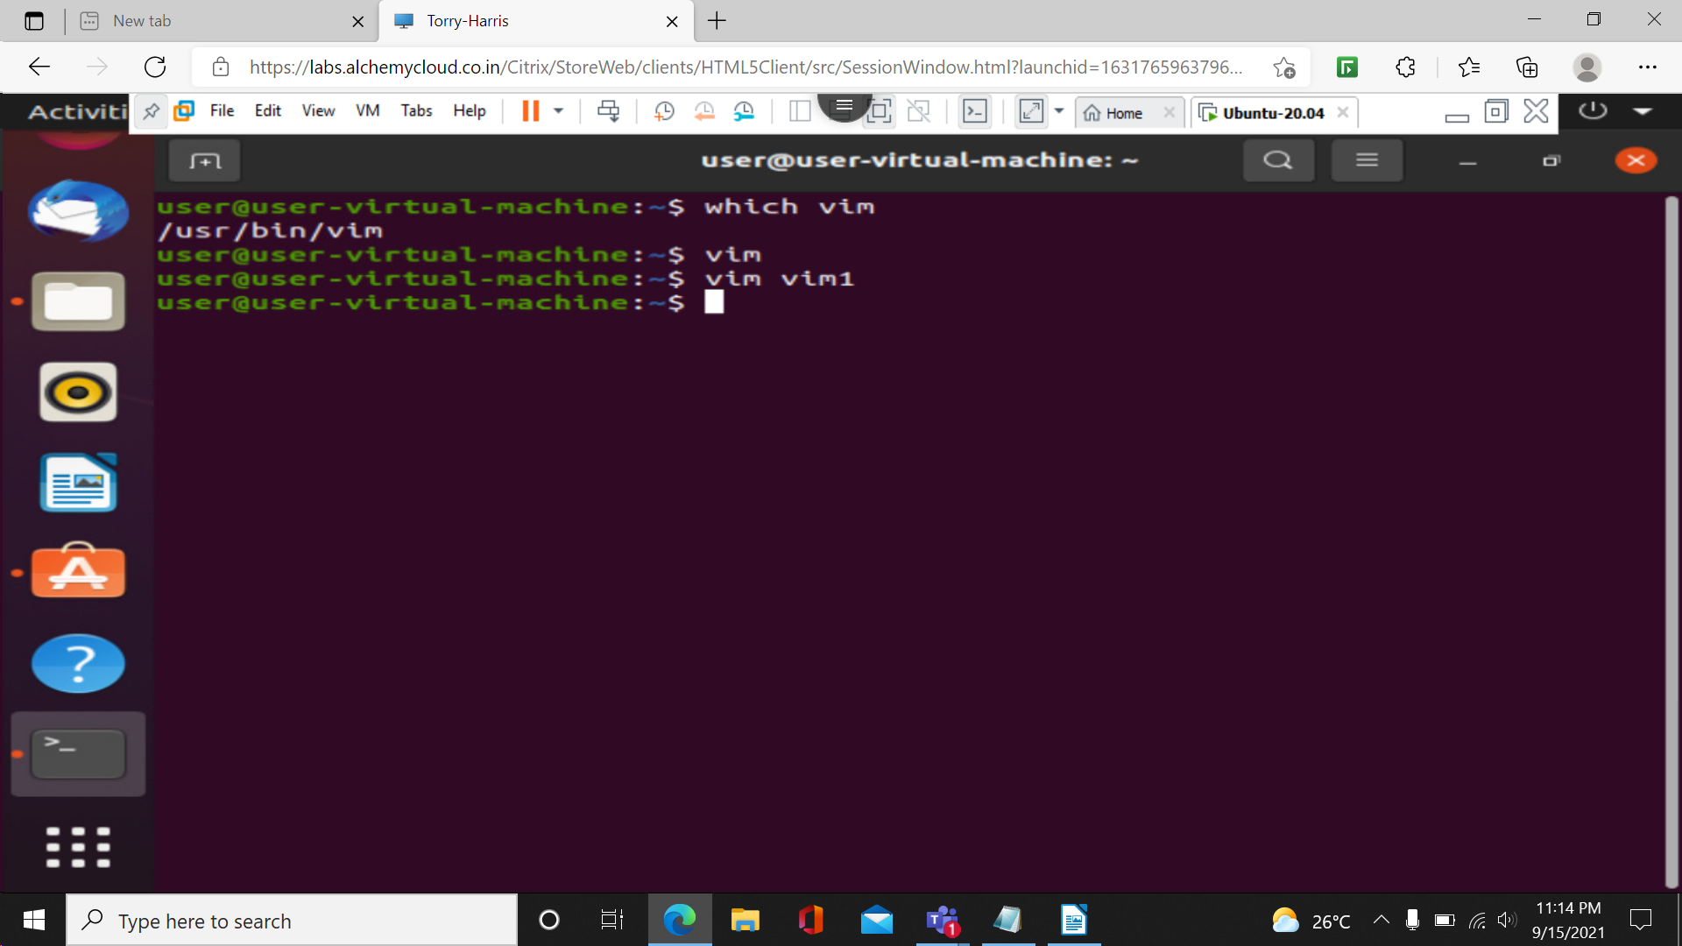

**find command:**used to search and locate the list of files and directories.

**find -name filename**

**find . -type type(f for file)**

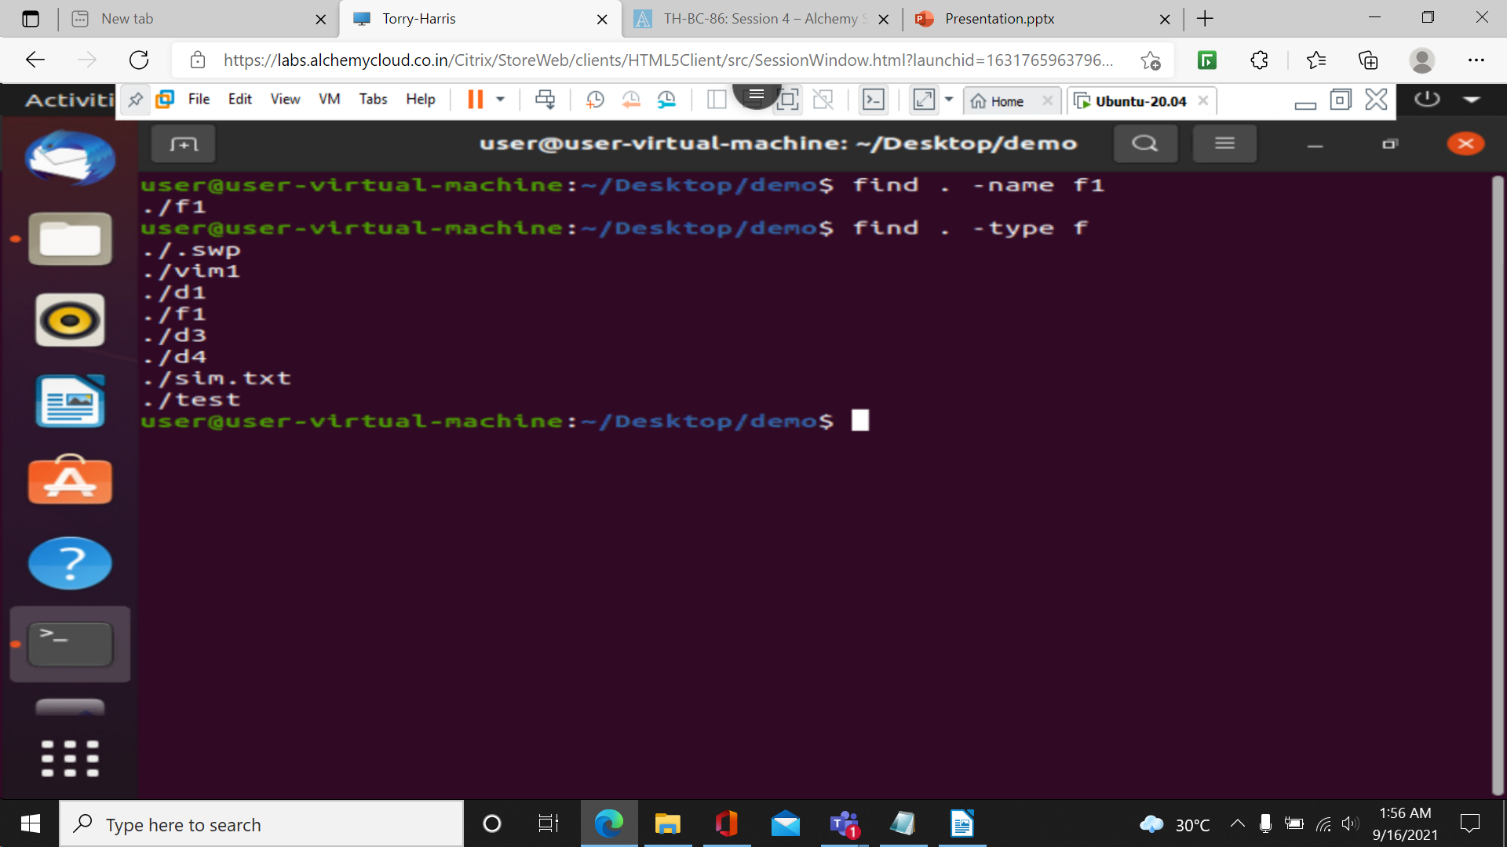**find . -type type(f for file) -name “*.java”**

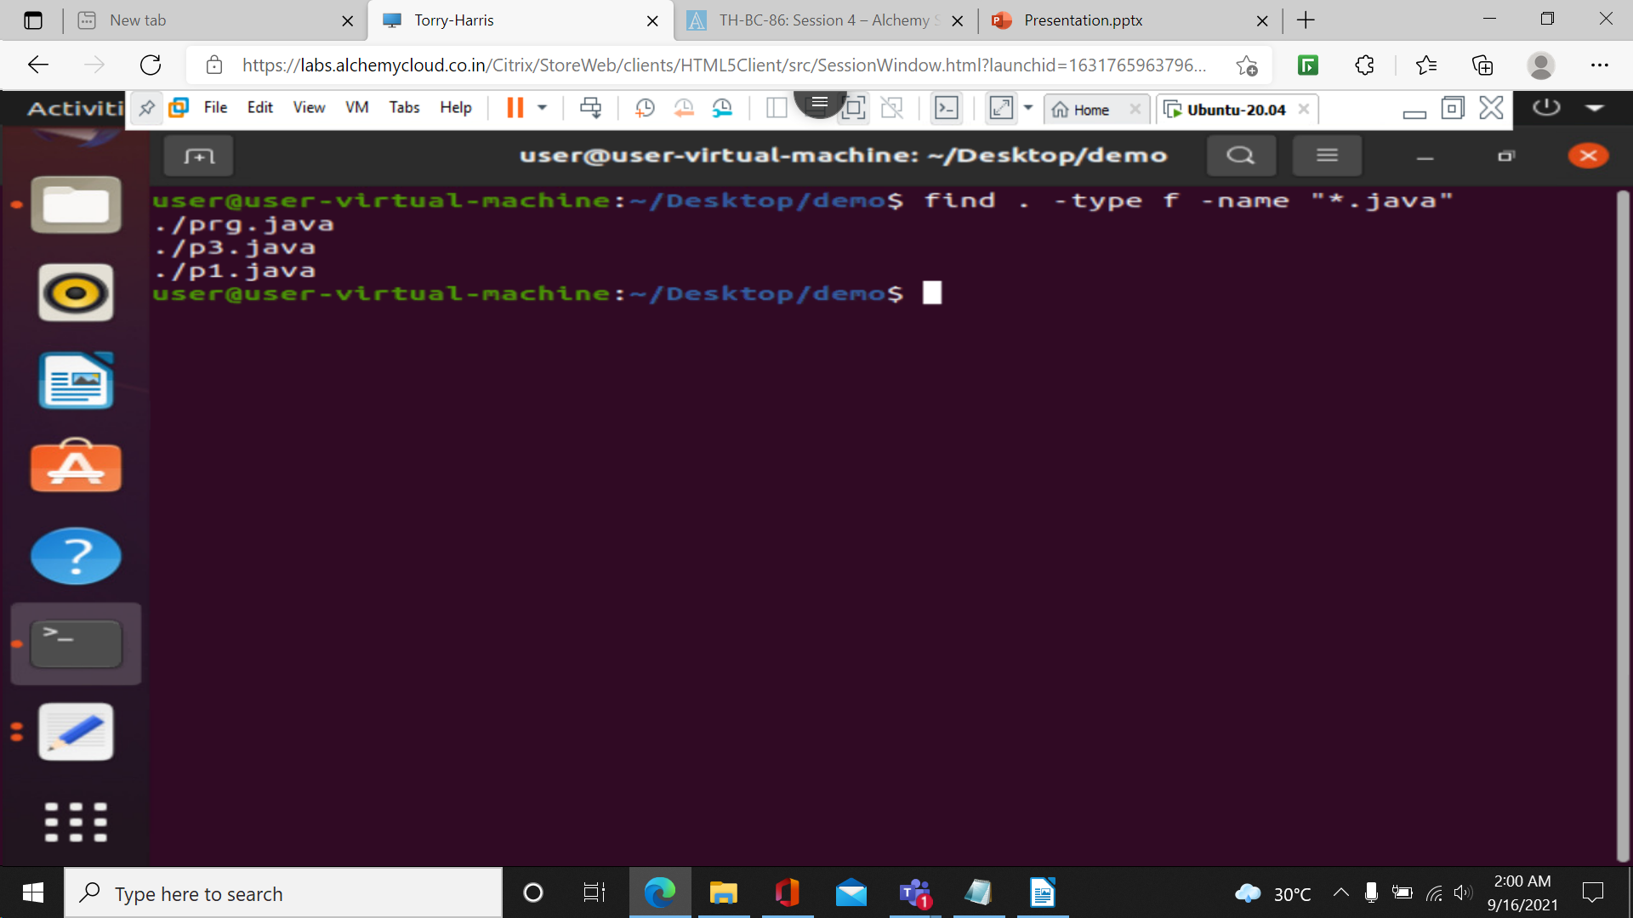

**Head command: used to print top n numbers of data . By default 10.**

**heat filename:**

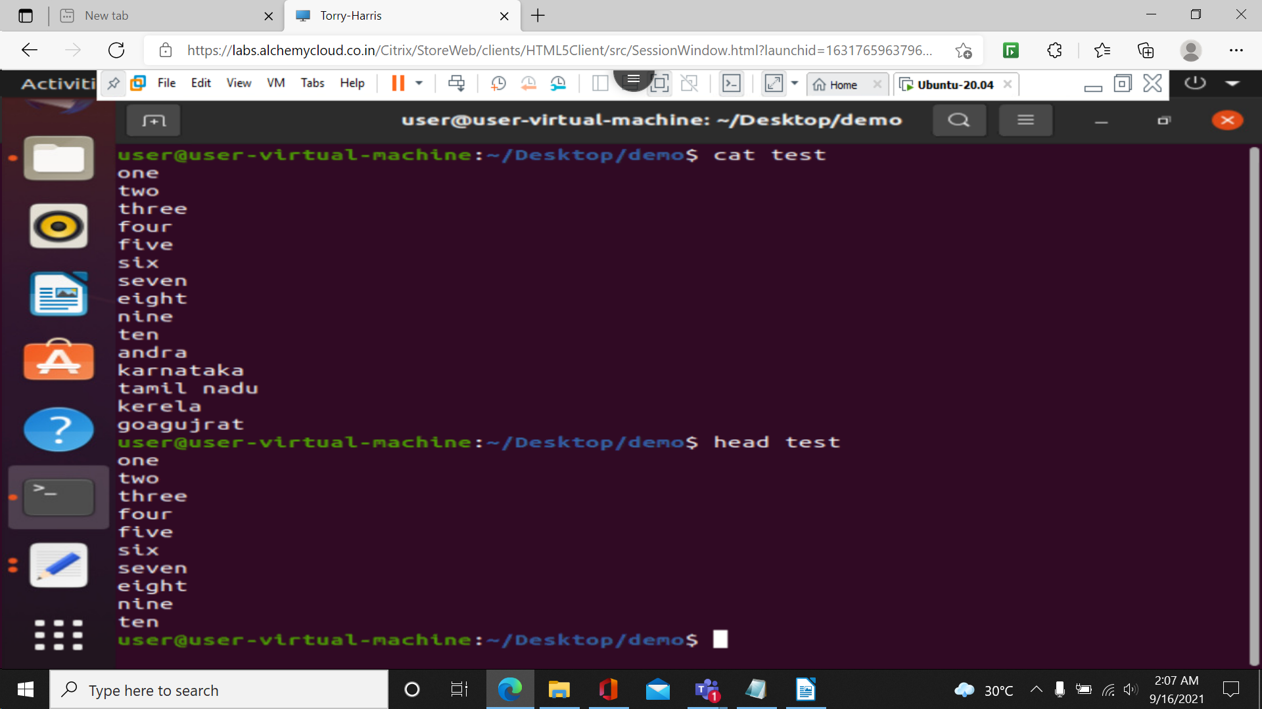

**head -n number filename:**

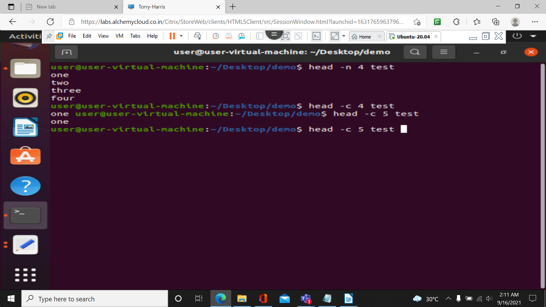

**head -q file1 file2**

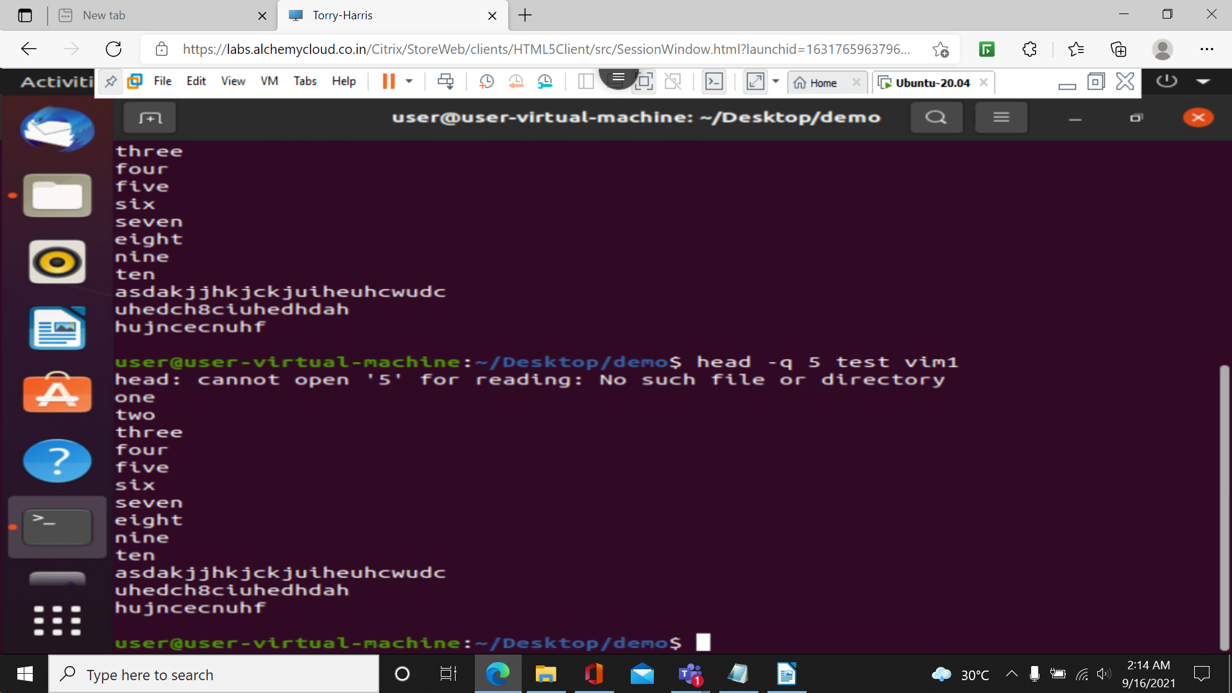

**Tail command:** it is a complimentary of head instead of from top it prints from bottom.

By default 10 lines are printed

Tail filename:first 10 lines from bottom

Tail -n number filename: mentioned number of lines from bottom

tail -c number filename: mentioned number of bytes from bottom

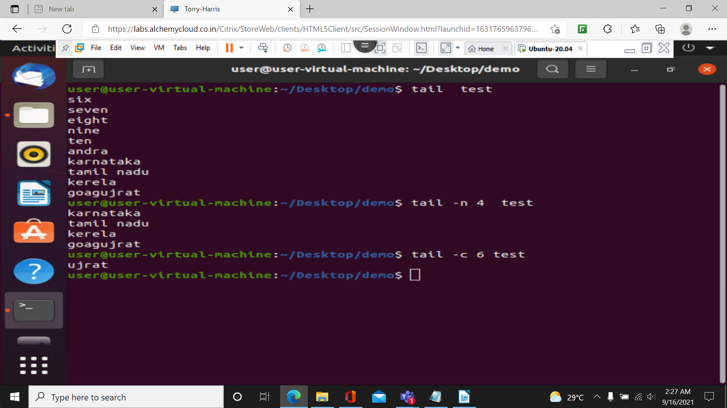

**Tail -q file1 file2 file3**

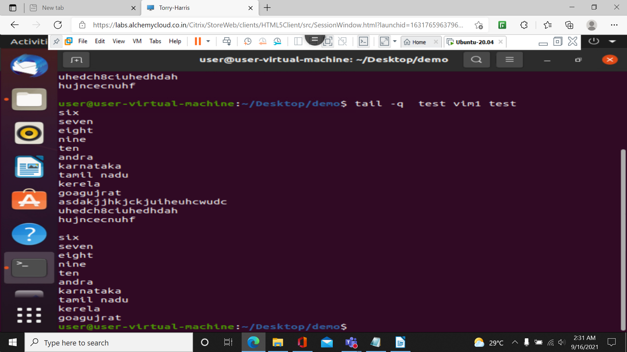

**Both head and tail can be pipelined with other commands or with each other.**

